1/ Copy thư mục CDB vào thư mục /home/oracle/CDB

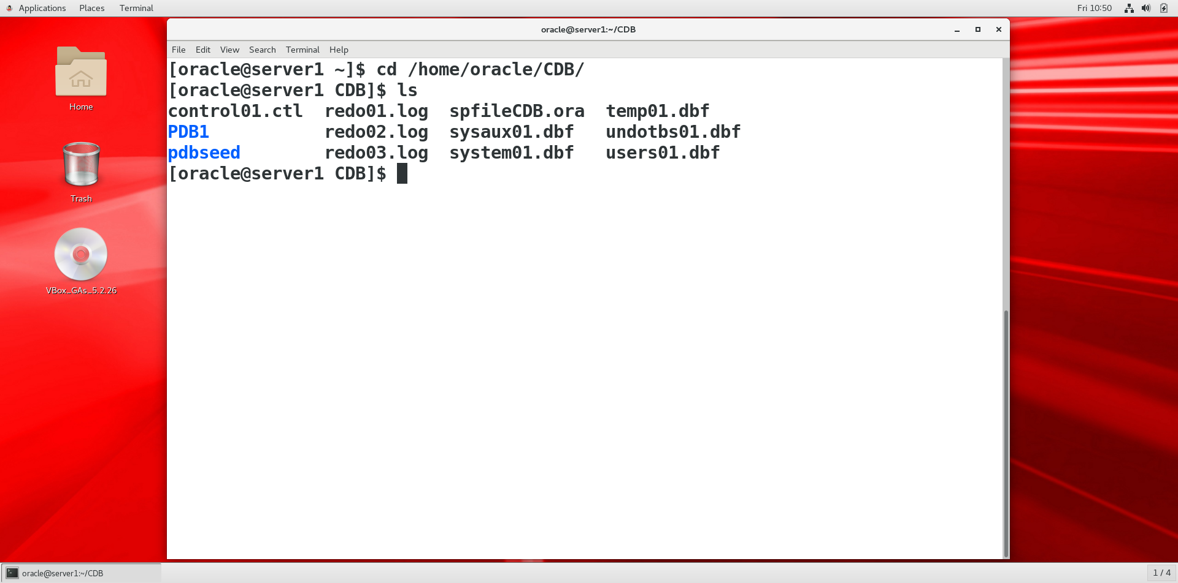

2/ Thiết lập môi trường:

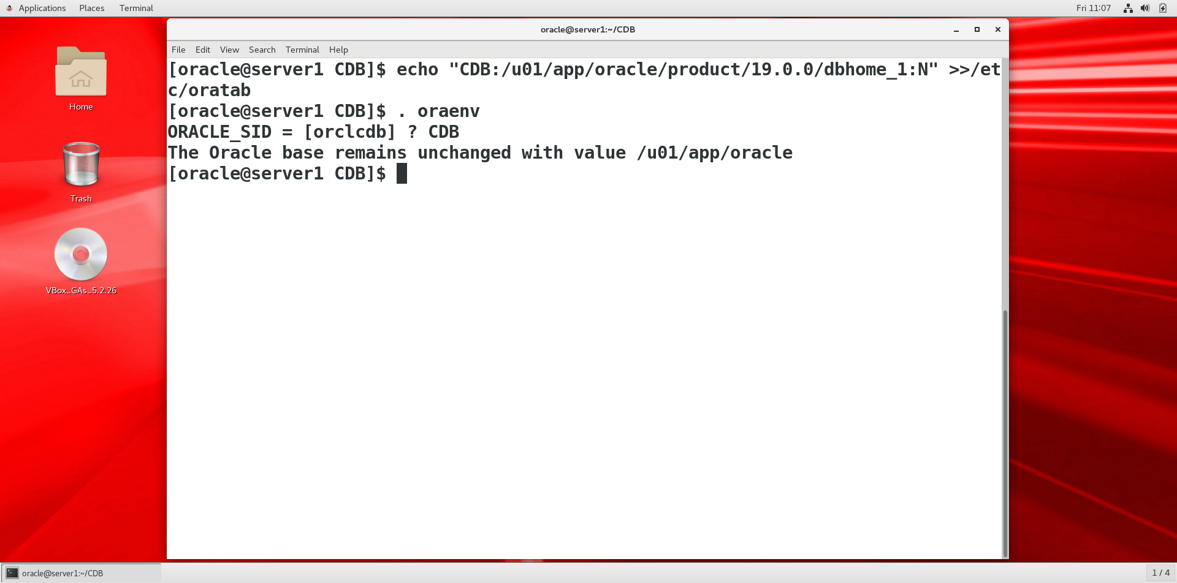

[oracle@server1 CDB]$ echo "CDB:/u01/app/oracle/product/19.0.0/dbhome_1:N" >>/etc/oratab

[oracle@server1 CDB]$ . oraenv

ORACLE_SID = [orclcdb] ? CDB

The Oracle base has been set to /u01/app/oracle

[oracle@server1 CDB]$

3/ Tạo pfile từ spfile

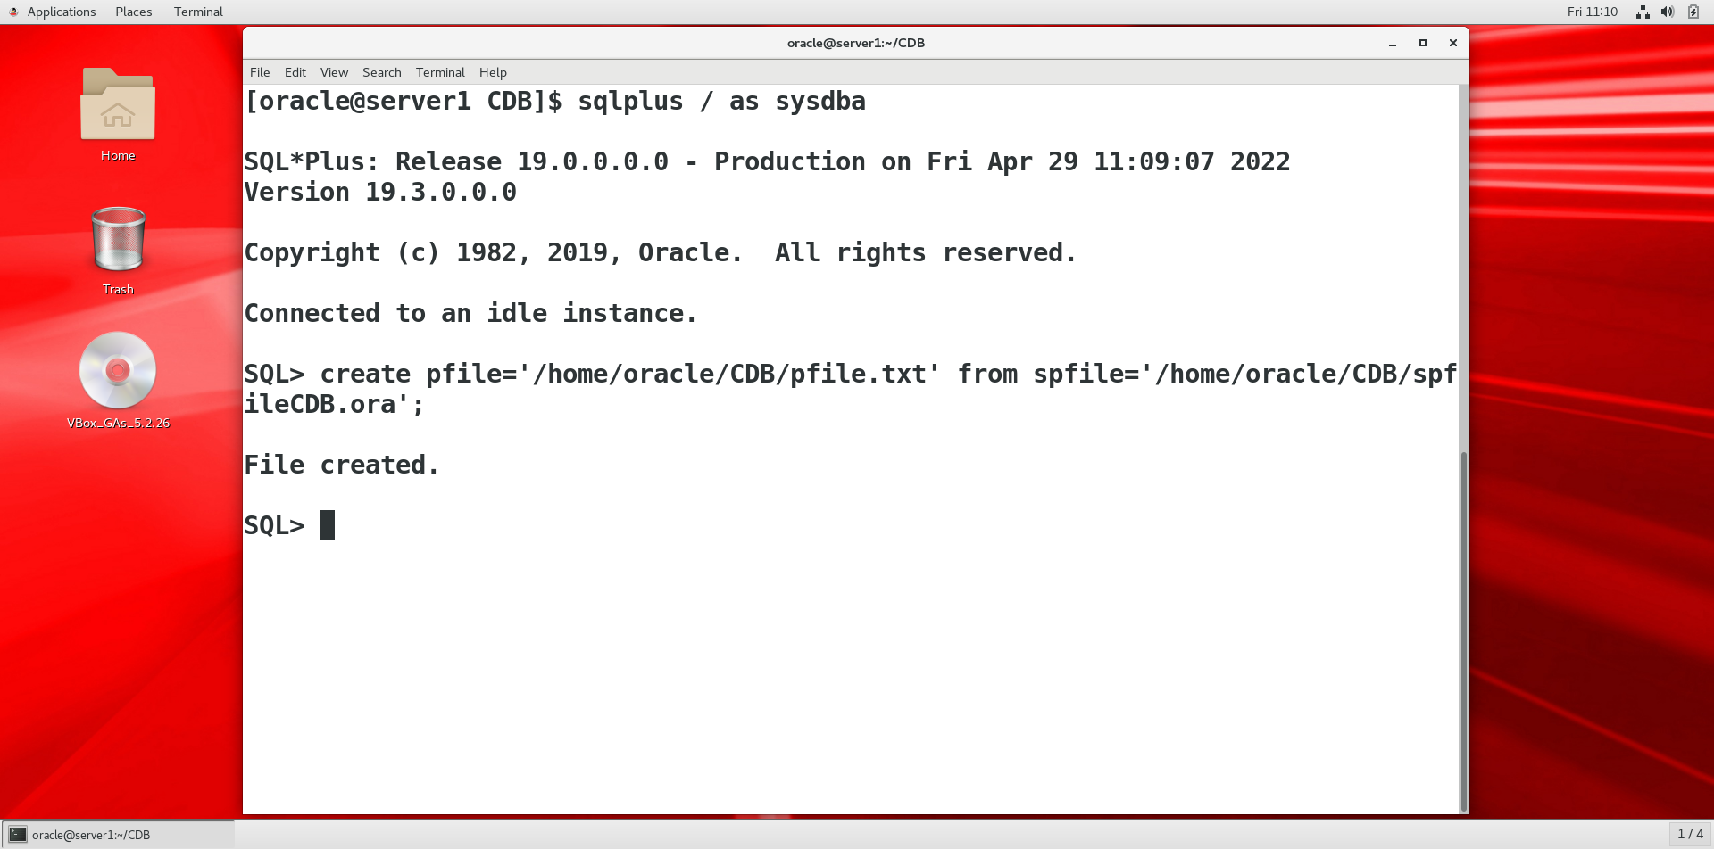

4/ Xem noi dung file pfile và thay doi de phù hợp máy mới:

-- Chung ta tao thu muc chua file audit:

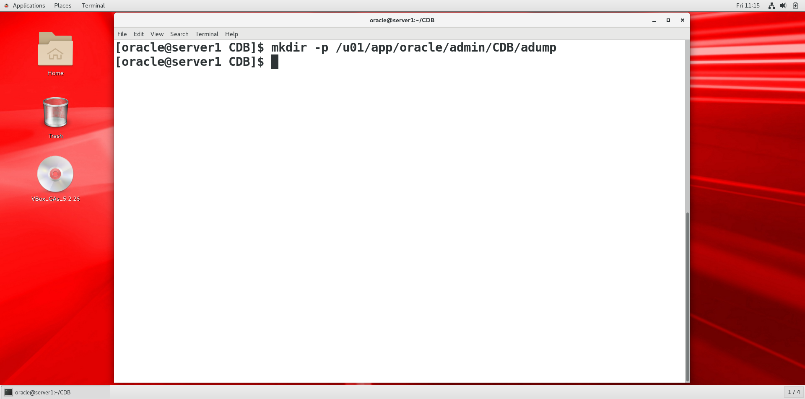

* Thay đổi các thông số còn lại như sau:

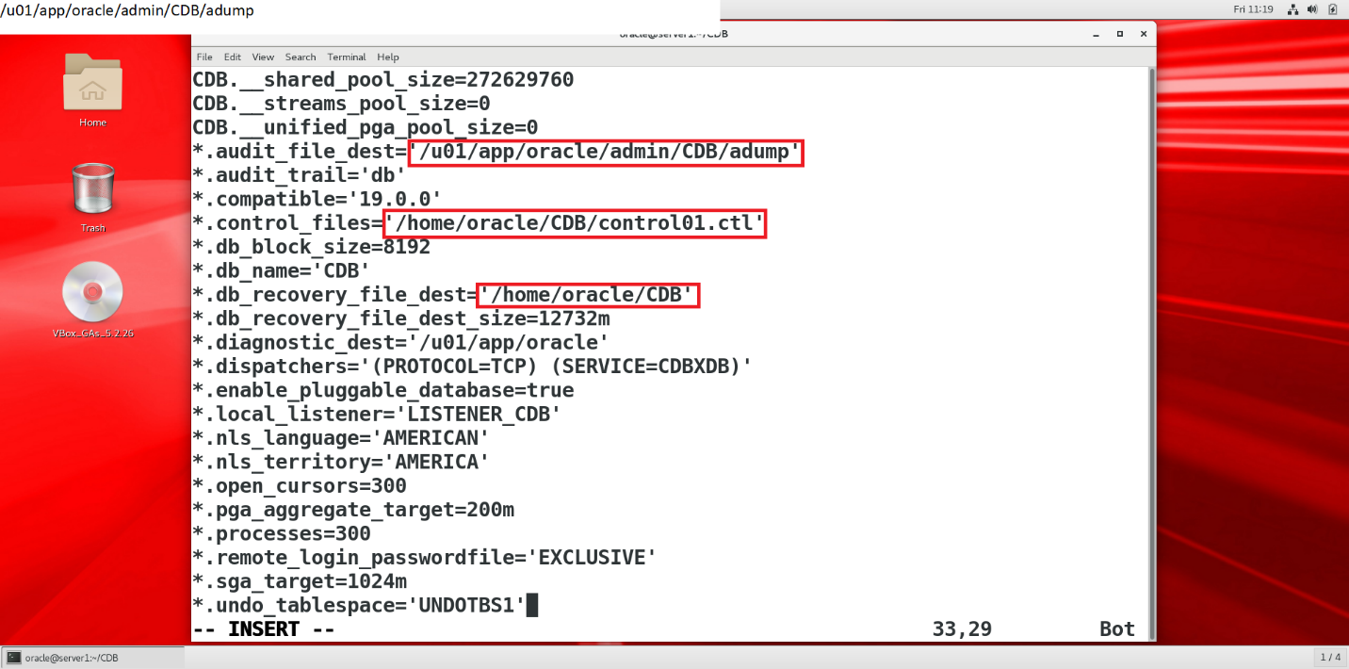

5/ Tạo lại spfile từ pfile đã sửa đổi:

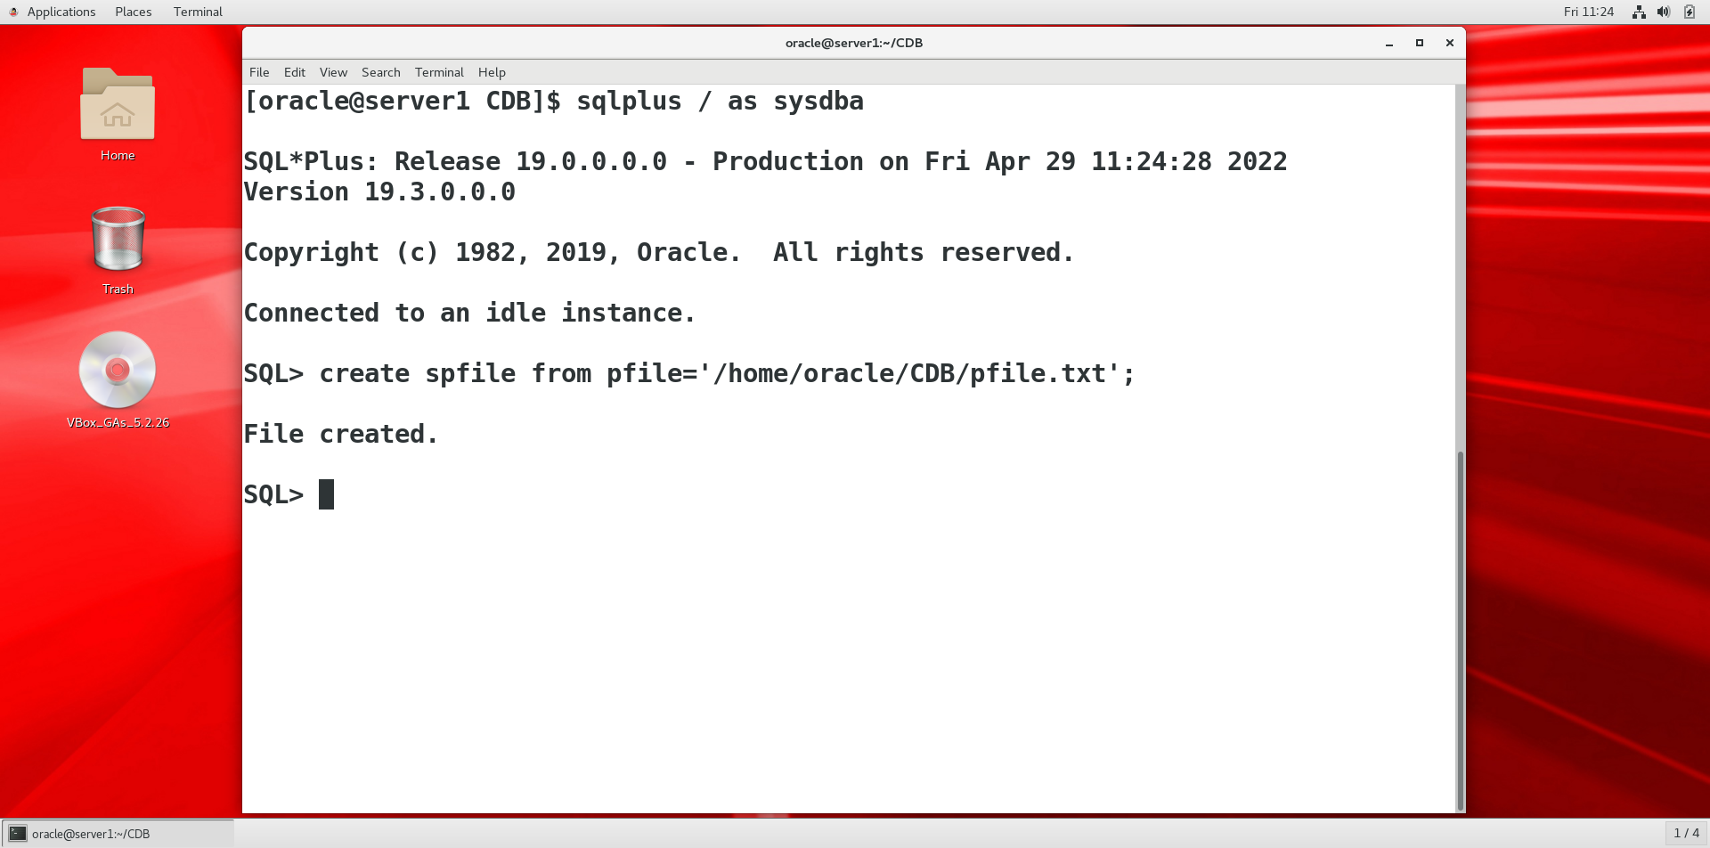

Xác định file spfile đã tạo thành công:

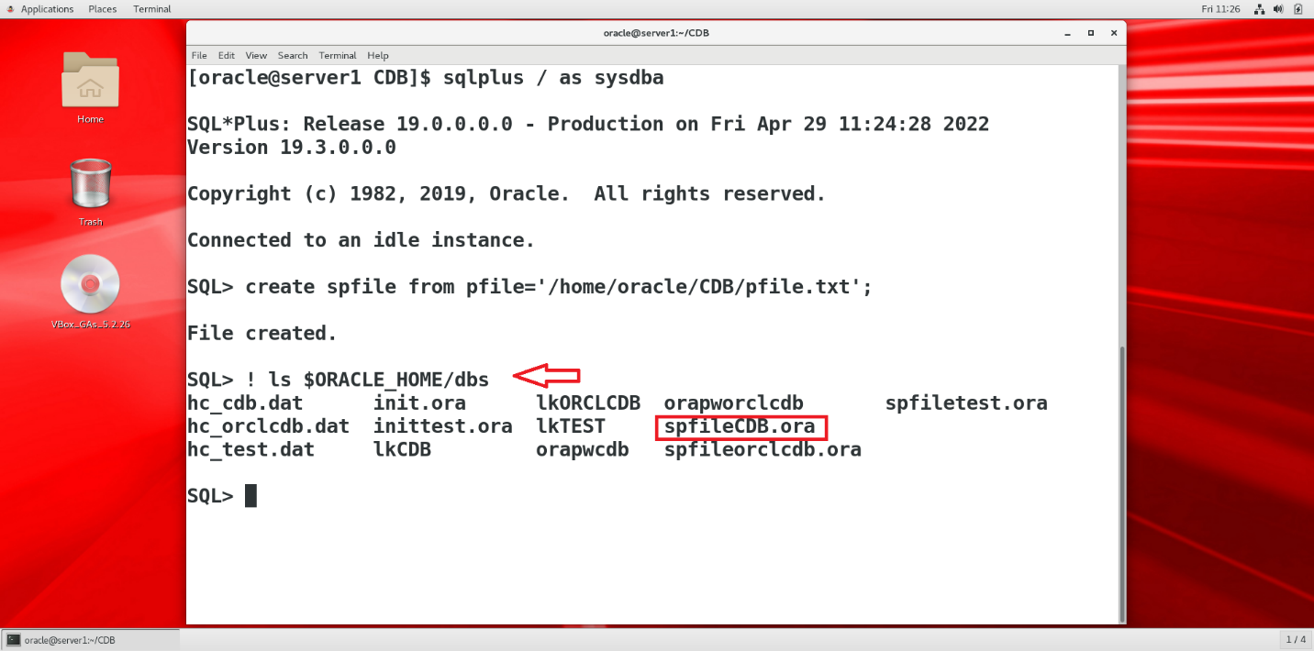

6/ Startup nomount vax ac dinh thong so controlfile đúng hay chưa:

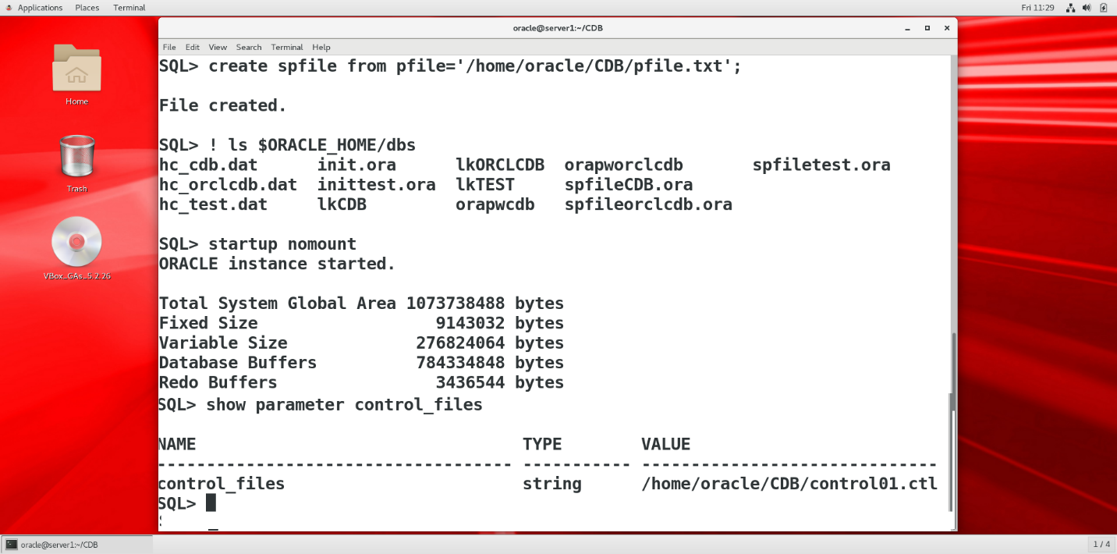

7/ Mount database ( Mở controlfile)

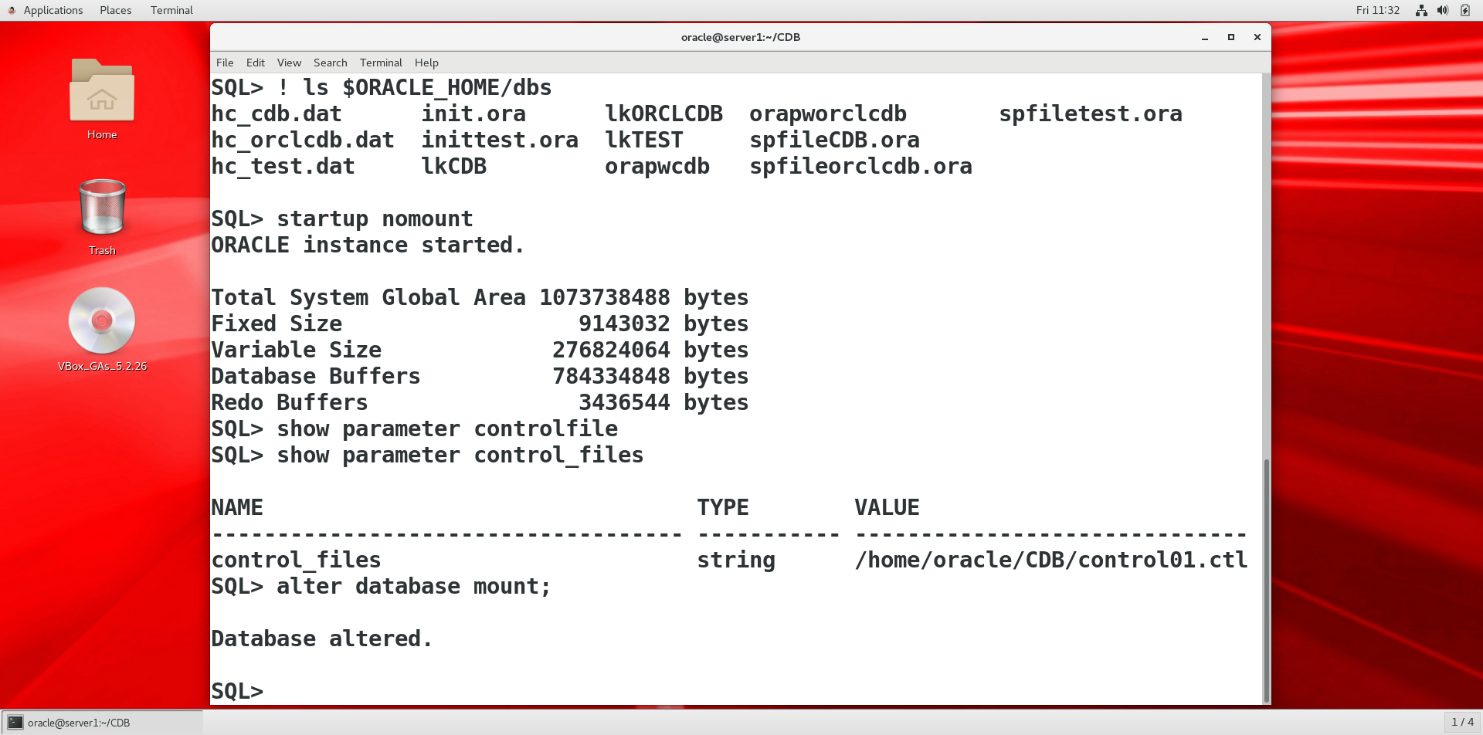

8/ Khảo sát thông tin DB trên server cũ: (Thông tin về file name, redo log file duoc lưu trong controlfile)

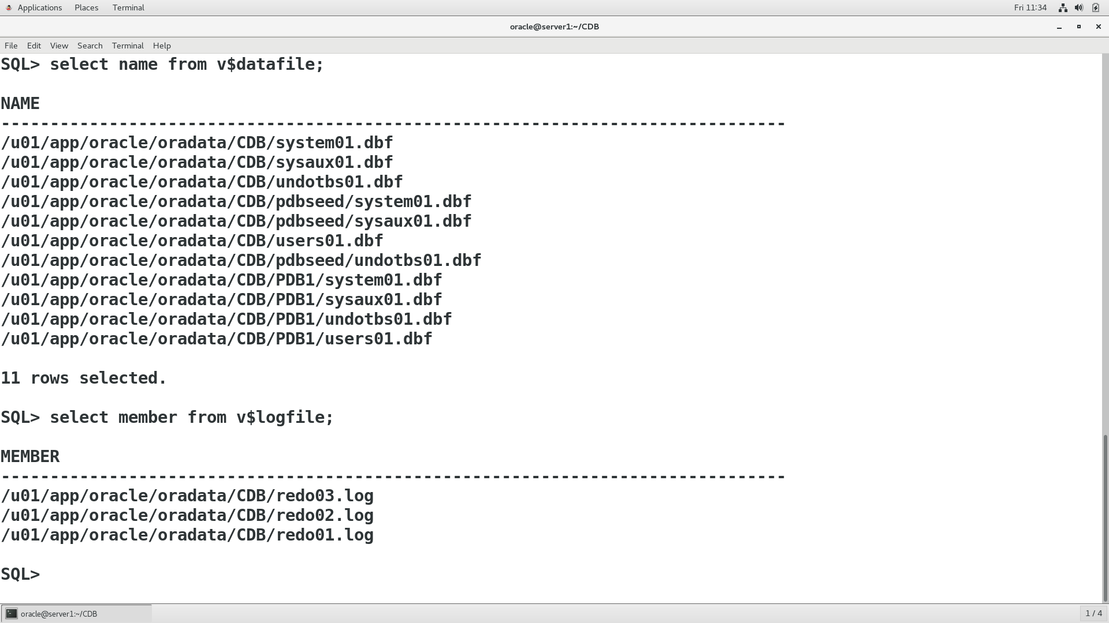

* Các Datafile và redo nay chung ta hien lưu trong thu mục /home/oracle/CDB. Cần phải cập nhật lại đường dẫn cho các file này.

9/ Chay nhung câu lệnh sau trong sqlplus với account sys

alter database rename file '/u01/app/oracle/oradata/CDB/system01.dbf' to '/home/oracle/CDB/system01.dbf';

alter database rename file '/u01/app/oracle/oradata/CDB/sysaux01.dbf' to '/home/oracle/CDB/sysaux01.dbf';

alter database rename file '/u01/app/oracle/oradata/CDB/undotbs01.dbf' to '/home/oracle/CDB/undotbs01.dbf';

alter database rename file '/u01/app/oracle/oradata/CDB/pdbseed/system01.dbf' to '/home/oracle/CDB/pdbseed/system01.dbf';

alter database rename file '/u01/app/oracle/oradata/CDB/pdbseed/sysaux01.dbf' to '/home/oracle/CDB/pdbseed/sysaux01.dbf';

alter database rename file '/u01/app/oracle/oradata/CDB/users01.dbf' to '/home/oracle/CDB/users01.dbf';

alter database rename file '/u01/app/oracle/oradata/CDB/pdbseed/undotbs01.dbf' to '/home/oracle/CDB/pdbseed/undotbs01.dbf';

alter database rename file '/u01/app/oracle/oradata/CDB/PDB1/system01.dbf' to '/home/oracle/CDB/PDB1/system01.dbf';

alter database rename file '/u01/app/oracle/oradata/CDB/PDB1/sysaux01.dbf' to '/home/oracle/CDB/PDB1/sysaux01.dbf';

alter database rename file '/u01/app/oracle/oradata/CDB/PDB1/undotbs01.dbf' to '/home/oracle/CDB/PDB1/undotbs01.dbf';

alter database rename file '/u01/app/oracle/oradata/CDB/PDB1/users01.dbf' to '/home/oracle/CDB/PDB1/users01.dbf';

--

alter database rename file '/u01/app/oracle/oradata/CDB/redo03.log' to '/home/oracle/CDB/redo03.log';

alter database rename file '/u01/app/oracle/oradata/CDB/redo02.log' to '/home/oracle/CDB/redo02.log';

alter database rename file '/u01/app/oracle/oradata/CDB/redo01.log' to '/home/oracle/CDB/redo01.log';

B10/ open database

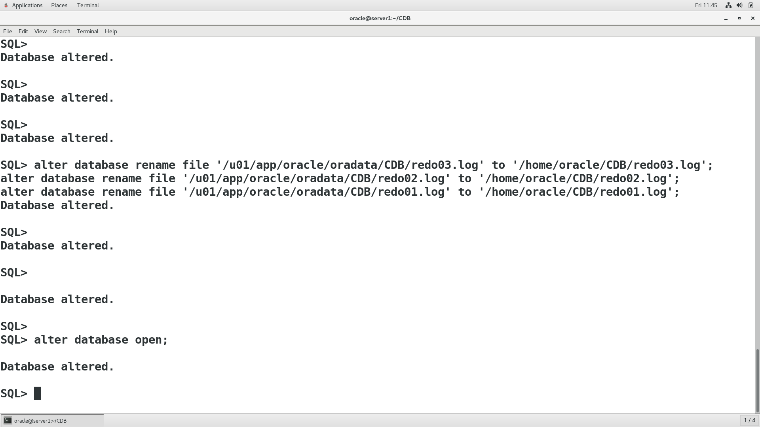

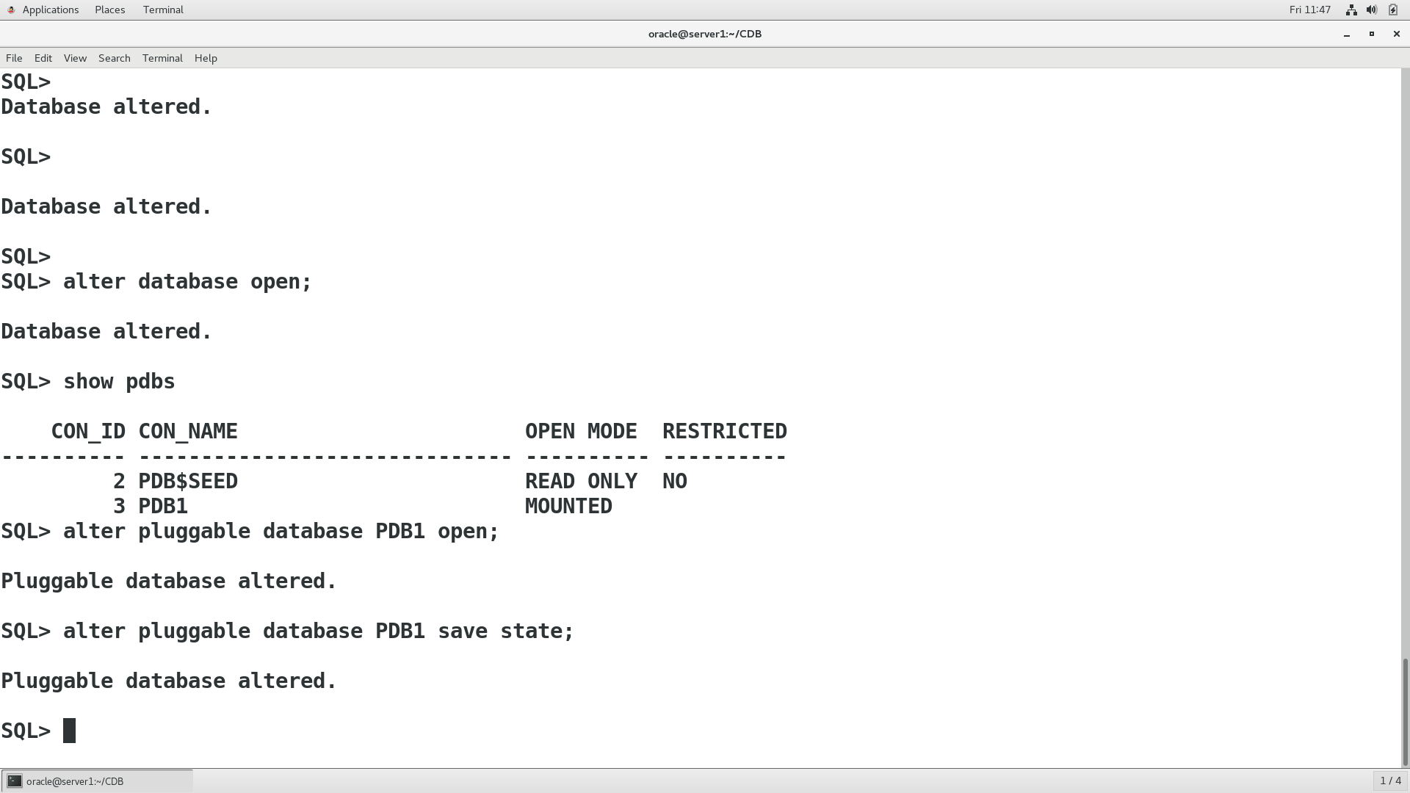

B11/ KIem tra listener

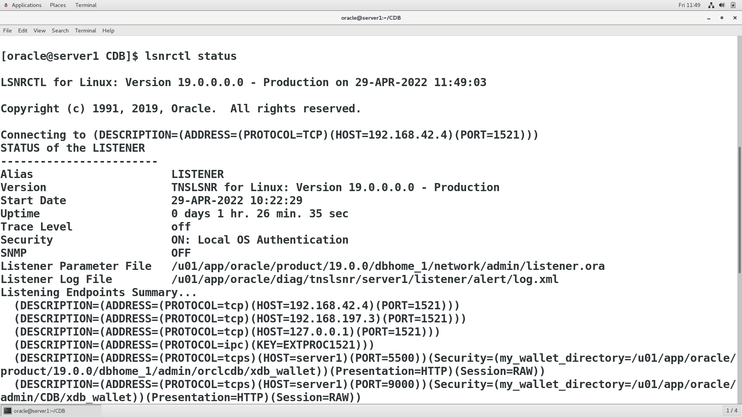

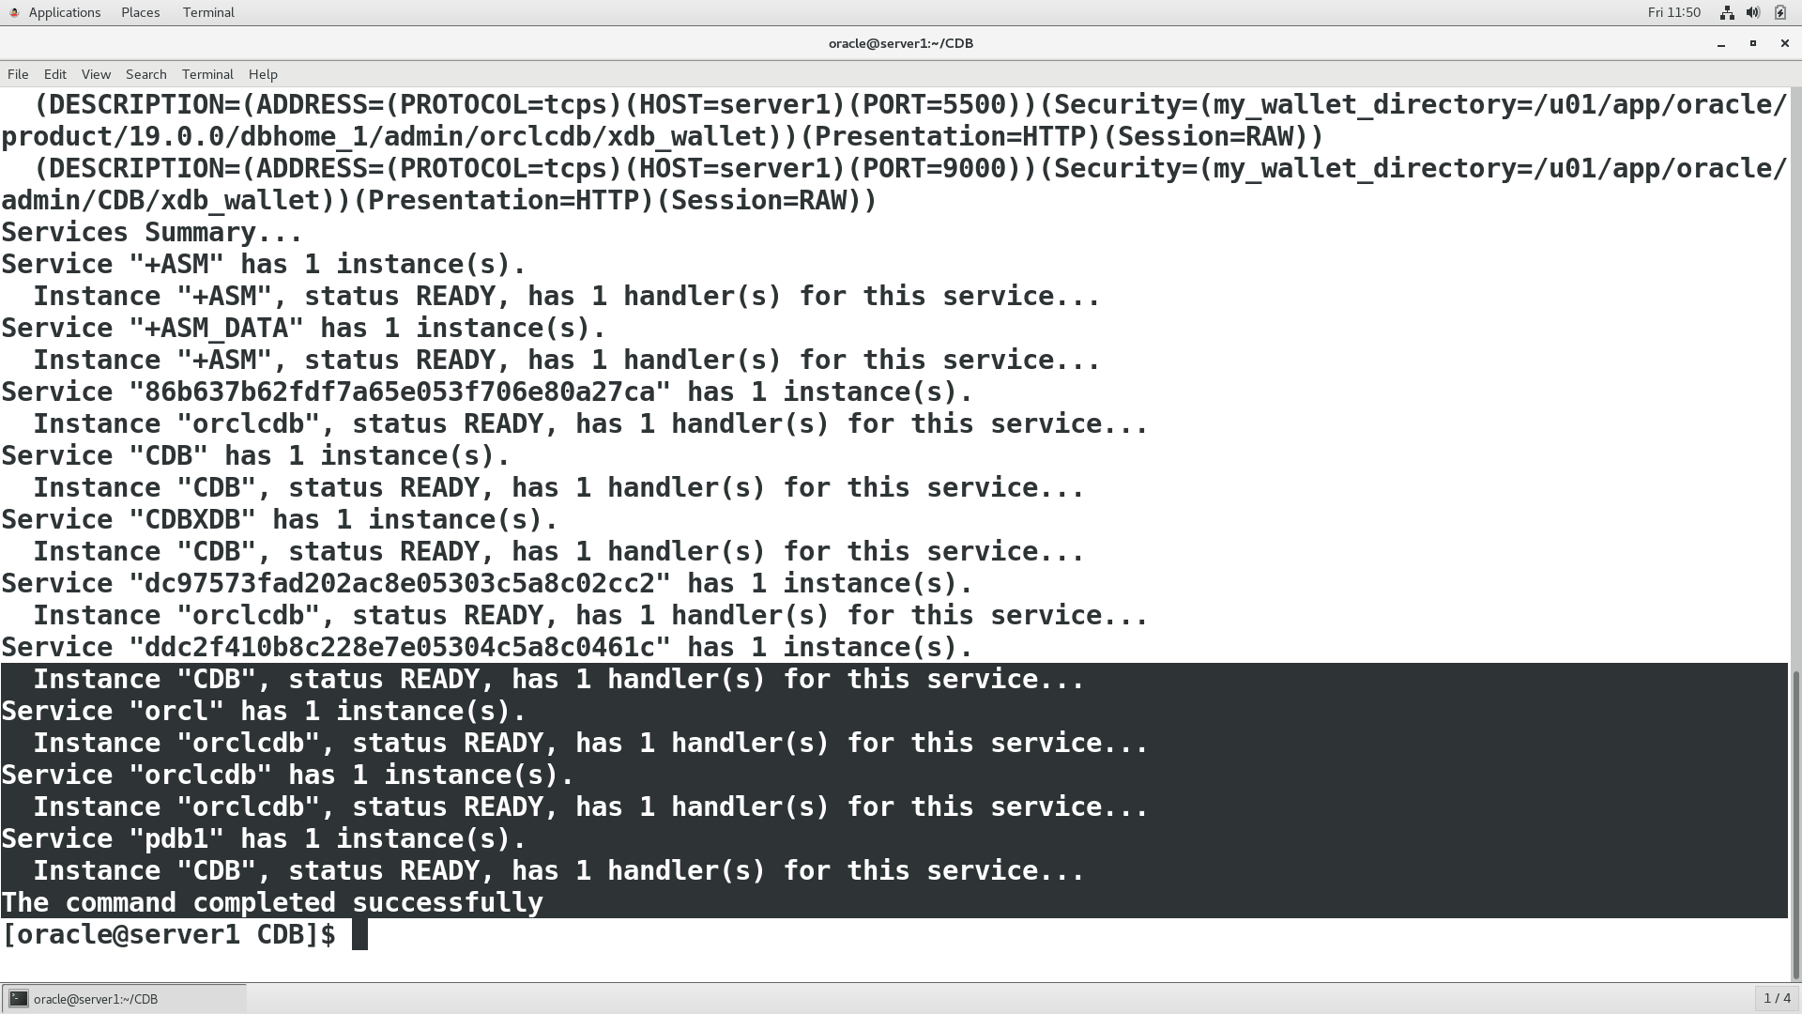

B12 cấu hình EM express

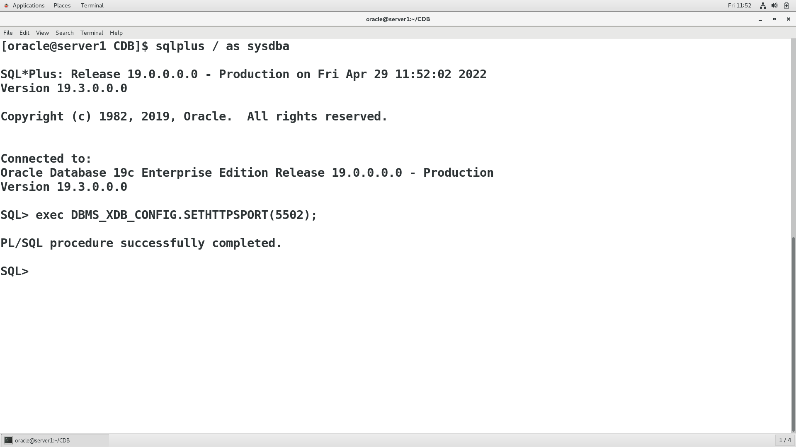

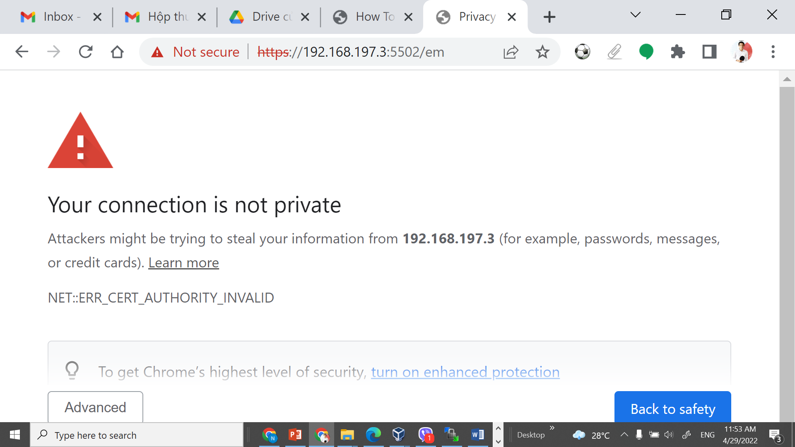

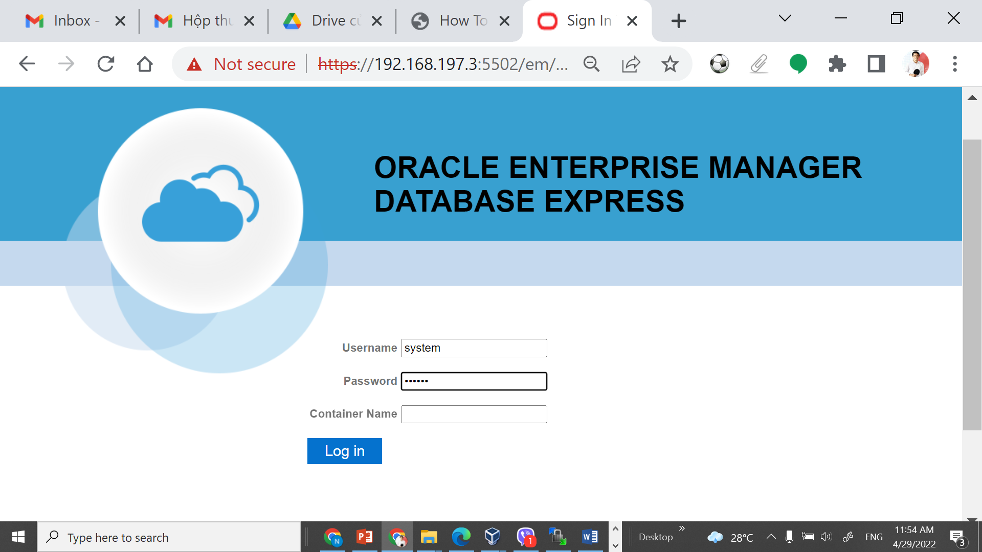

User system pass oracle

